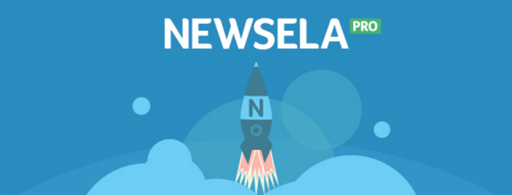

Dear Families,

Great news, our school has a Newsela PRO subscription! Newsela curates the most relevant and interesting nonfiction content, including daily news articles, famous speeches, primary sources, and biographies. Every article is written at 5 different reading levels, making it easy for an entire class to read the same content at a level that’s just right for each reader.

With Newsela PRO, classroom teachers and administrators are able to check for understanding with quizzes and customizable writing prompts. Readers can also monitor their own progress and performance on Newsela.

Here are some ways you can get involved:

- Sign up for a Parent account to assign articles to your reader. Visit www.newsela.com to register. For instructions on how to sign up check out our Quick Start Guide for Parents.

- Download the Newsela iOS application to take your Newsela browser experience on to any iOS device. This gives you access to our entire library online or offline.

- Read articles together. Discuss current events, ask questions, and make connections. Encouraging your reader to choose topics of interest helps strengthen their love for reading and learning.

Your reader can sign in to Newsela anytime by visiting www.newsela.com/signin:

Newsela Username:

Newsela Password:

